Name: Pranali Sonawane
Subject: MCSA
Date: 4-12-2025
Lab: Active Directory
- Open Server1 Download Active directory:
Add roles and Features next next Server Selection Server Role Select
1. Active Directory Domain Service
2.DNS Server next automatically select(group policy Management ) Confirmation install
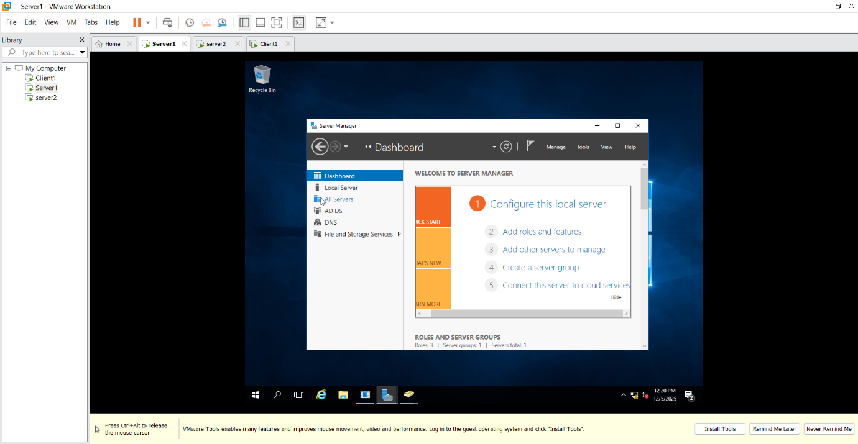
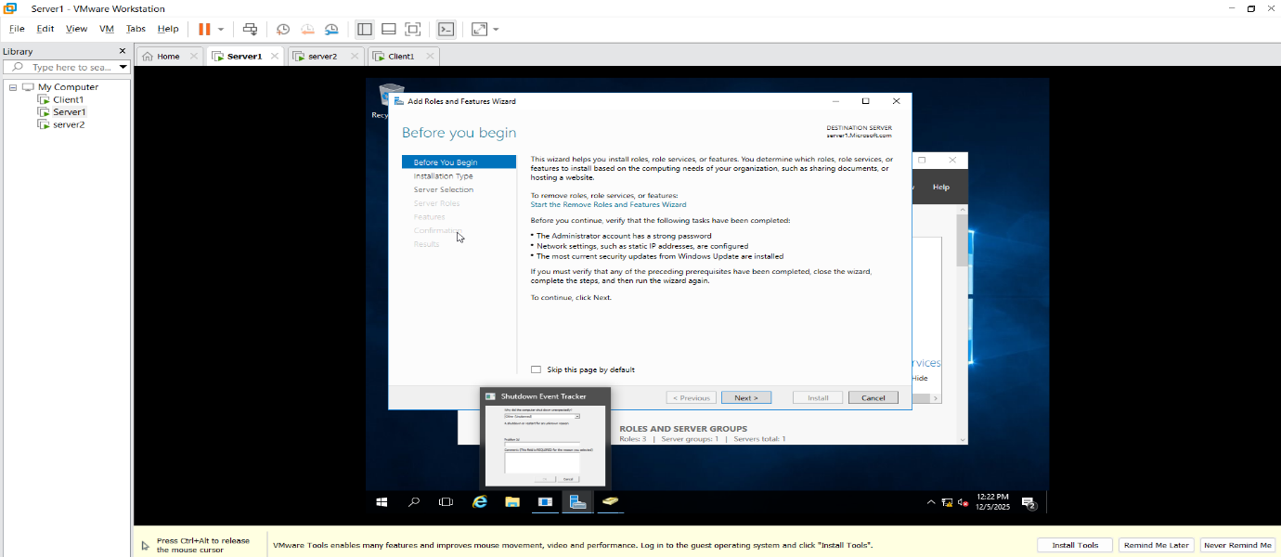
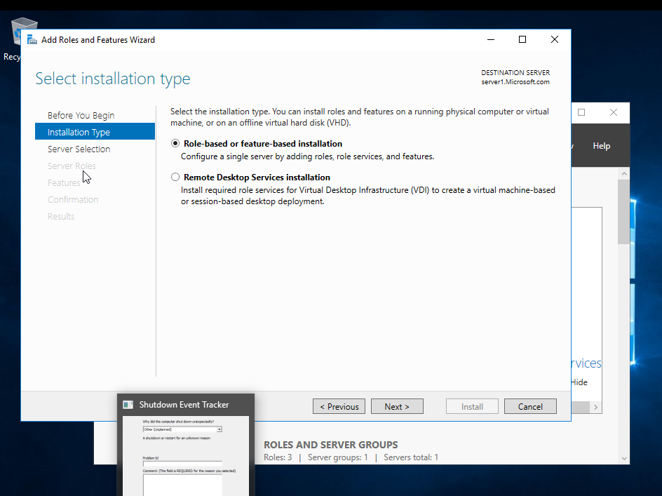

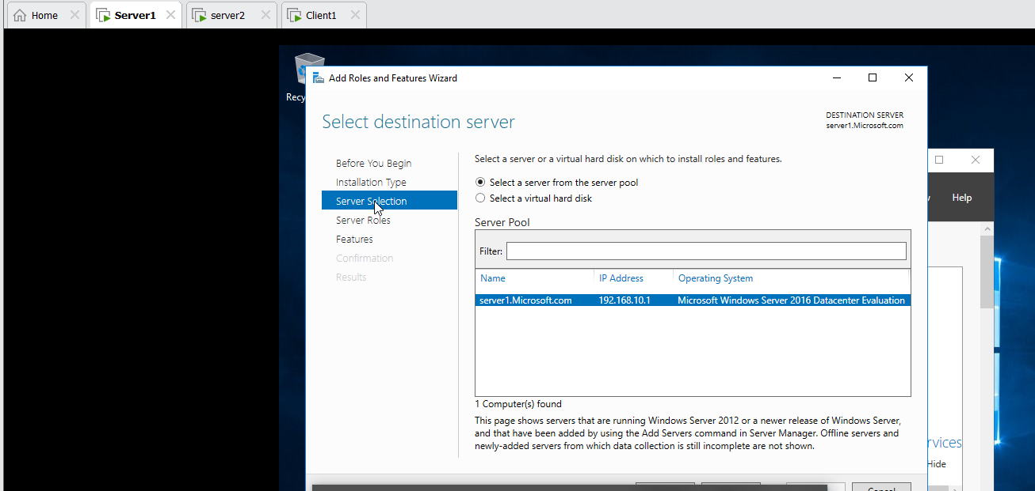
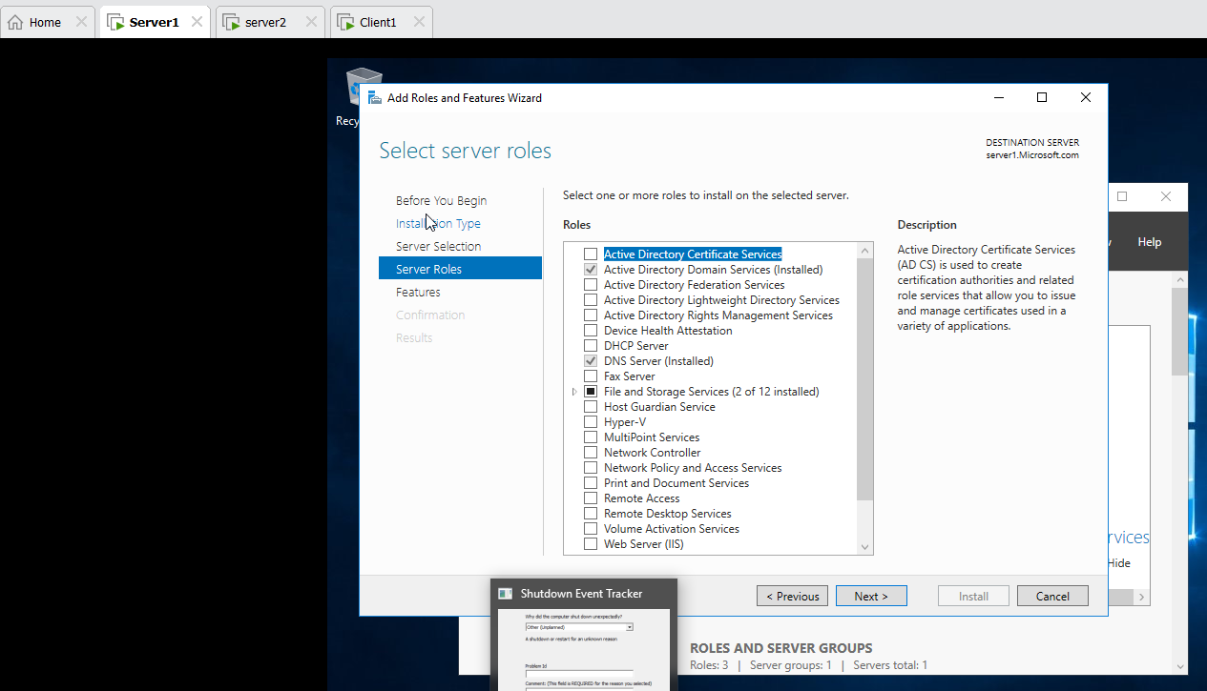
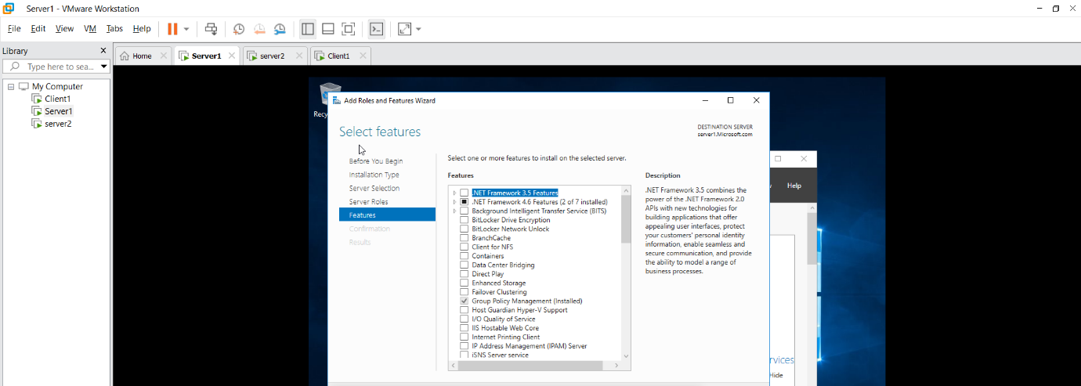
- Go to the Promote/ Deployment Operation:
Add a new router root domain name : Microsoft.com
Problem Domain Controller Options Password@123 next next NETBIOS Domain Name : MICROSOFT

- First Check Server1,Server2 and Client1 ping to each other.

- Server2 Local server Workgroup change Domain Microsoft.com username(Administrator) Password(Password@123)

- Client1 Setting About Advanced setting name DomainchangeMicrosoft.comusername(Administrator) Password(Password@123)

- Server1 Local server Workgroup change Domain Microsoft.com username(Administrator) Password(Password@123)
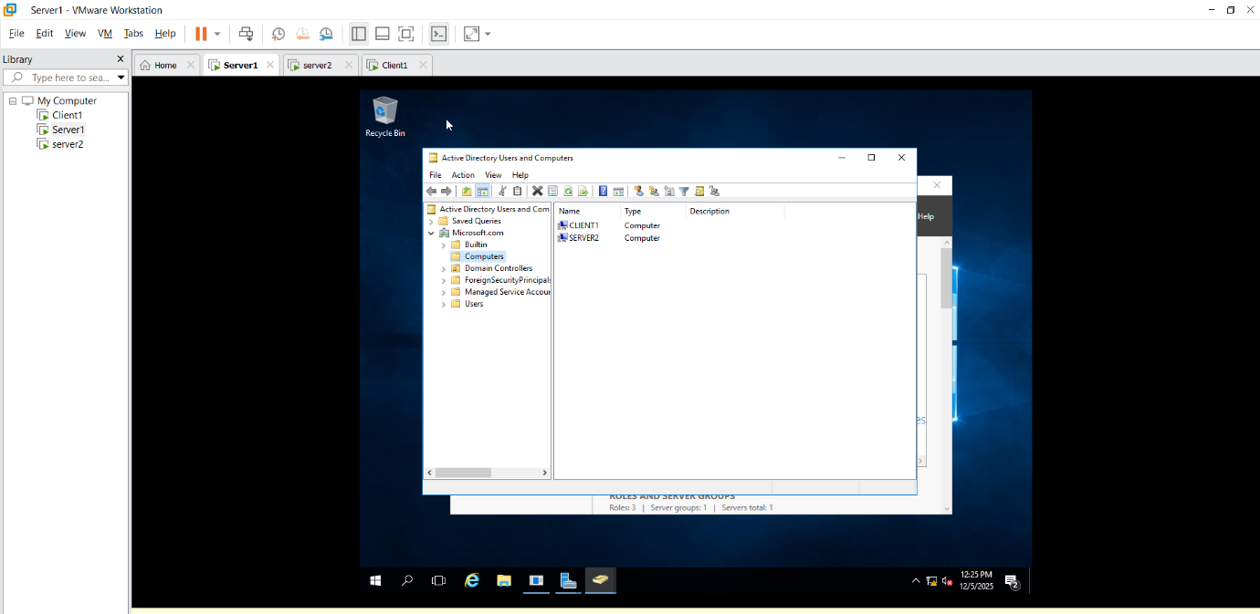

7.Server1 Tools Active directory user and computers Microsoft Users Right click on User 3 user create same as go to the users 4 group create(each group has 3 users)
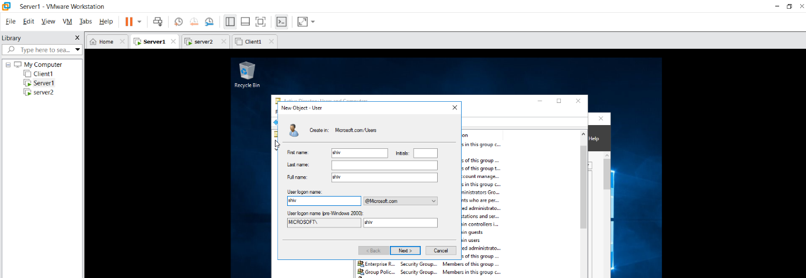

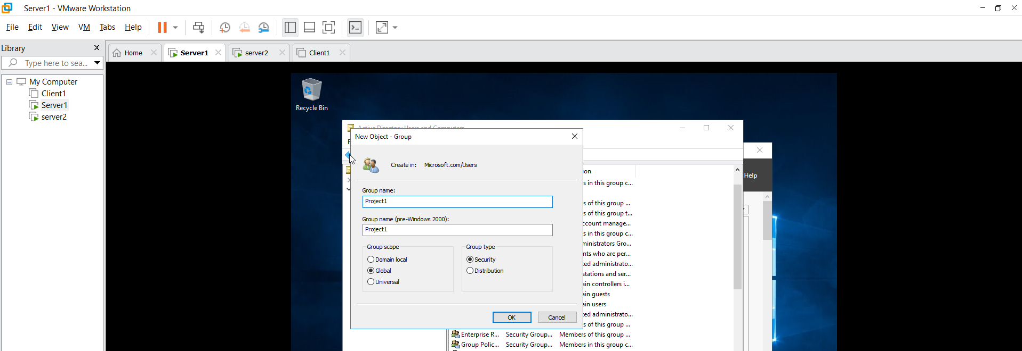

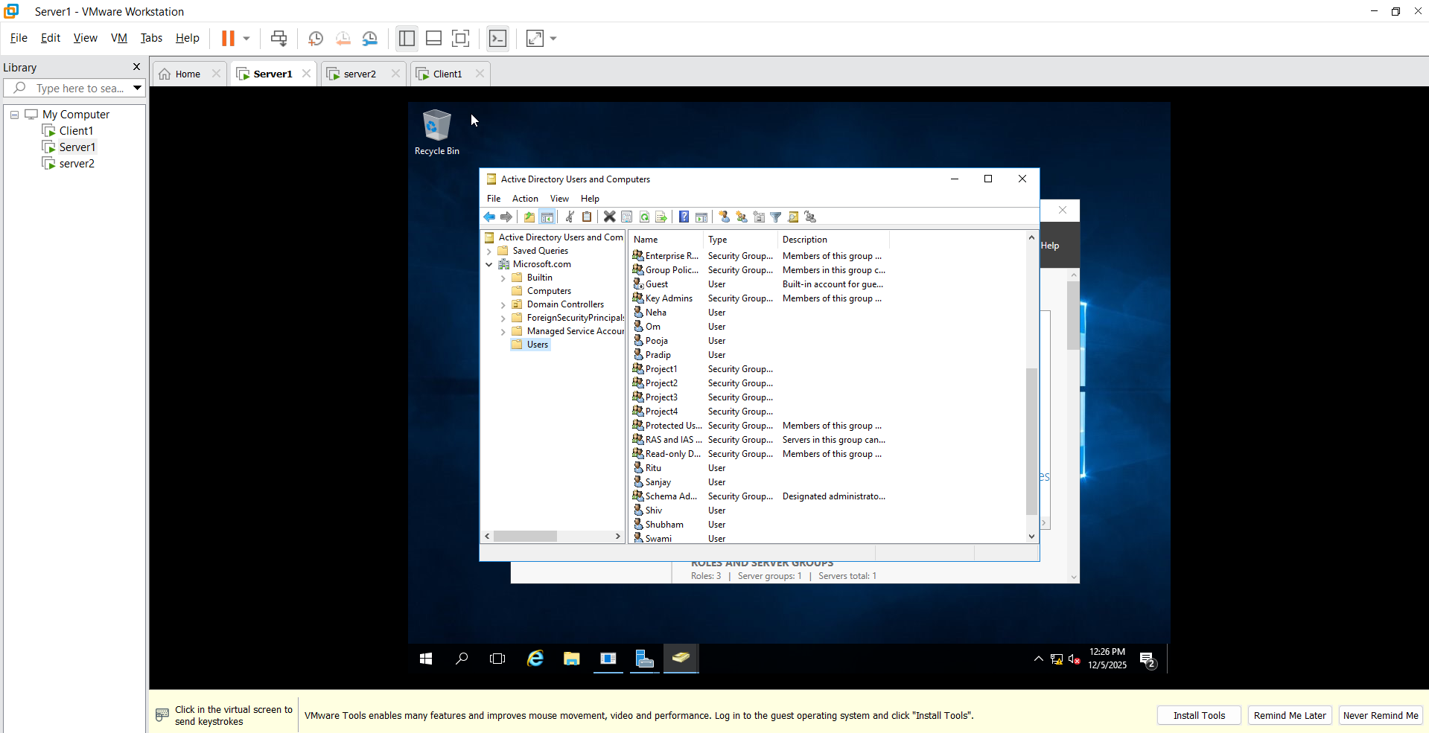

8.Power on Server2 VM other user login by username and Password (in server1 create user add name and password )
9.Power on Client1 VM other user login by username and Password (in server1 create user add name and password )

